1-Relational Databases
# Source: AI Source: Provided by: [Data Path: Persons Table -> ID Column: 1, Name_En Column: Motasem Essam] -> From: [ChatGPT] on [6/10/2026]
A Relational Database is a type of database that stores data in tables, and the relationships between the data are also stored using keys (like primary and foreign keys).
Think of it like a set of interconnected spreadsheets, where each table has rows and columns, and you can link data from different tables using shared values.

🧱 Key Concepts
# Source: AI Source: Provided by: [Data Path: Persons Table -> ID Column: 1, Name_En Column: Motasem Essam] -> From: [ChatGPT] on [6/10/2026]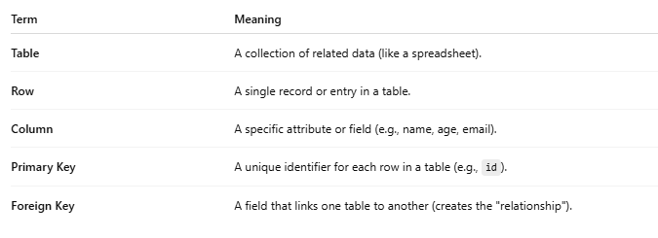
Term | Meaning
Table | A collection of related data (like a spreadsheet).
Row | A single record or entry in a table.
Column | A specific attribute or field (e.g., name, age, email).
Primary Key | A unique identifier for each row in a table (e.g., id).
Foreign Key | A field that links one table to another (creates the "relationship").

🗃️ Example
# Source: AI Source: Provided by: [Data Path: Persons Table -> ID Column: 1, Name_En Column: Motasem Essam] -> From: [ChatGPT] on [6/10/2026]
Users Table
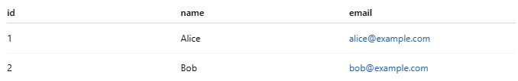
id | name | email
1 | Alice | alice@example.com
2 | Bob | bob@example.com
Orders Table
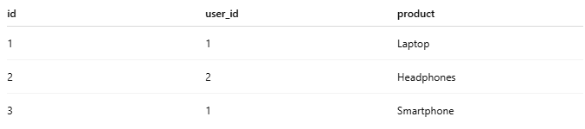
id | user_id | product
1 | 1 | Laptop
2 | 2 | Headphones
3 | 1 | Smartphone
- user_id in the Orders table is a foreign key that links to id in the Users table.
- This tells us who made each order.

💻 Popular Relational Database Systems
# Source: AI Source: Provided by: [Data Path: Persons Table -> ID Column: 1, Name_En Column: Motasem Essam] -> From: [ChatGPT] on [6/10/2026]
- MySQL
- PostgreSQL
- SQLite
- Oracle Database
- Microsoft SQL Server

📜 Uses SQL (Structured Query Language)
# Source: AI Source: Provided by: [Data Path: Persons Table -> ID Column: 1, Name_En Column: Motasem Essam] -> From: [ChatGPT] on [6/10/2026]
Example query to get all orders made by "Alice":
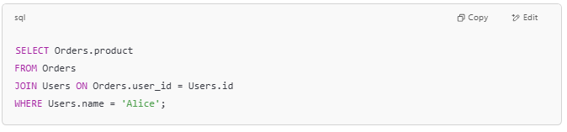
SELECT Orders.product
FROM Orders
JOIN Users ON Orders.user_id = Users.id
WHERE Users.name = 'Alice';

✅ Why Use Relational Databases?
# Source: AI Source: Provided by: [Data Path: Persons Table -> ID Column: 1, Name_En Column: Motasem Essam] -> From: [ChatGPT] on [6/10/2026]
- Organized and structured data
- Easy to search and filter
- Enforces data integrity through relationships
- Standardized using SQL

Let me know if you want a simple project example or code demo using MySQL or SQLite!

2-Non-Relational Databases
# Source: AI Source: Provided by: [Data Path: Persons Table -> ID Column: 1, Name_En Column: Motasem Essam] -> From: [ChatGPT] on [6/10/2026]
A Non-Relational Database, also known as a NoSQL database, is a type of database that does not use tables with fixed columns and rows like relational (SQL) databases. Instead, it stores data in more flexible formats such as:
- Documents
- Key-value pairs
- Graphs
- Wide-columns
These databases are designed to handle large volumes of data, support scalability, and work well with unstructured or semi-structured data.

🔑 Key Features of Non-Relational Databases
# Source: AI Source: Provided by: [Data Path: Persons Table -> ID Column: 1, Name_En Column: Motasem Essam] -> From: [ChatGPT] on [6/10/2026]
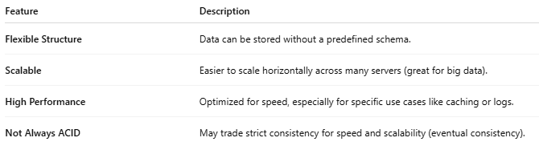
Feature | Description
Flexible Structure | Data can be stored without a predefined schema.
Scalable | Easier to scale horizontally across many servers (great for big data).
High Performance | Optimized for speed, especially for specific use cases like caching or logs.
Not Always ACID | May trade strict consistency for speed and scalability (eventual consistency).

🗃️ Common Types of NoSQL Databases
# Source: AI Source: Provided by: [Data Path: Persons Table -> ID Column: 1, Name_En Column: Motasem Essam] -> From: [ChatGPT] on [6/10/2026]
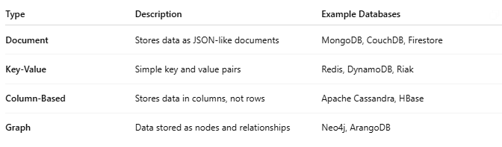
Type | Description | Example Databases
Document | Stores data as JSON-like documents | MongoDB, CouchDB, Firestore
Key-Value | Simple key and value pairs | Redis, DynamoDB, Riak
Column-Based | Stores data in columns, not rows | Apache Cassandra, HBase
Graph | Data stored as nodes and relationships | Neo4j, ArangoDB

📄 Example: Document Database (MongoDB)
# Source: AI Source: Provided by: [Data Path: Persons Table -> ID Column: 1, Name_En Column: Motasem Essam] -> From: [ChatGPT] on [6/10/2026]
A user might be stored like this in JSON format:
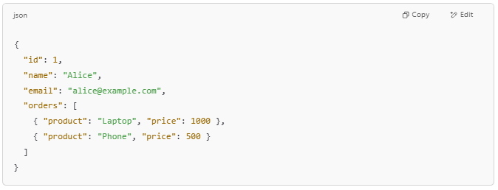
{
"id": 1,
"name": "Alice",
"email": "alice@example.com",
"orders": [
{ "product": "Laptop", "price": 1000 },
{ "product": "Phone", "price": 500 }
]
}

Notice:
- No fixed table schema
- Orders are nested inside the user

✅ Why Use Non-Relational Databases?
# Source: AI Source: Provided by: [Data Path: Persons Table -> ID Column: 1, Name_En Column: Motasem Essam] -> From: [ChatGPT] on [6/10/2026]
- When data is unstructured or changes frequently
- For real-time applications (chat apps, IoT, etc.)
- For large-scale apps needing fast performance and easy scaling
- To store logs, user activity, analytics, etc.

🆚 Relational vs Non-Relational
# Source: AI Source: Provided by: [Data Path: Persons Table -> ID Column: 1, Name_En Column: Motasem Essam] -> From: [ChatGPT] on [6/10/2026]
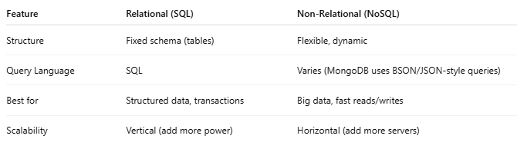
Feature | Relational (SQL) | Non-Relational (NoSQL)
Structure | Fixed schema (tables) | Flexible, dynamic
Query Language | SQL | Varies (MongoDB uses BSON/JSON-style queries)
Best for | Structured data, transactions | Big data, fast reads/writes
Scalability | Vertical (add more power) | Horizontal (add more servers)

